A. Analysis Equipment
- Thermo iCAP Qc Inductively-coupled Plasma Mass Spectrometer (ICP-MS)
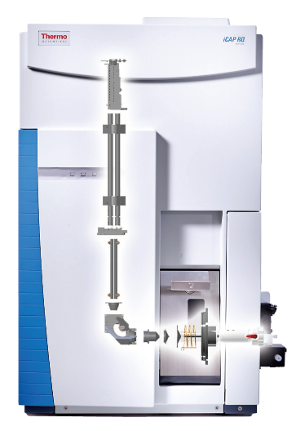
The iCAP Qc ICP-MS provides high quality analyses for most elements in the periodic table. Analysis is possible across the entire mass range using pure He as a collision gas. Detection limits are routinely in the low parts-per-billion (ppb, μg/L) to parts-per-trillion (ppt, ng/L) range for most elements. High elemental sensitivity and low backgrounds also make the iCAP Qc ICP-MS the ideal instrument for coupled applications, such as speciation, laser ablation and nanoparticles studies. An autosampler with the system can accommodate up to 50 x 10-mL samples.
- npQuant Plug-in for Qtegra ISDS software. An extra feature of the MACF ICP-MS system is a software plugin that simplifies detection and characterization of individual nanoparticles suspended in liquid samples.
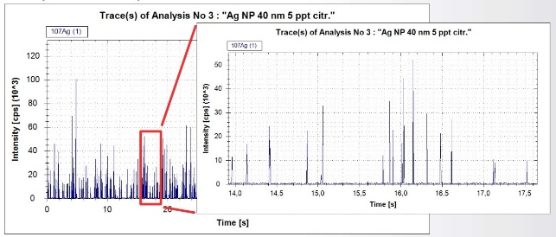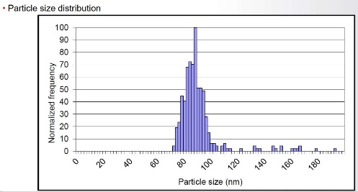
This feature aids users with development of nano-based biomarker assays and with studies of nanomaterials in consumer products or environmental samples.

- Milestone DMA-80 Direct Mercury Analyzer
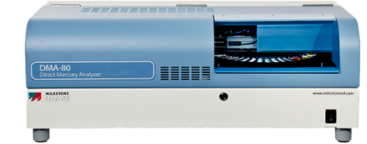
The DMA-80 provides dedicated analysis for mercury in solid, liquid, and gas samples with an analysis time of 5 minute per sample and no sample preparation. It operates by thermal decomposition of the sample, capture of mercury vapor by amalgamation, and atomic absorption detection following thermal desorption. Per sample quantitation ranges from 0.01 to 1,500 ng Hg with a detection limit of 0.001 ng Hg. Sample types include biological (tissue or plants), environmental (water or soil), and petrochemical (oil or natural gas). An autosampler with the system can accommodate up to 50 x 1-g samples.

- Hitachi Z-2000 Zeeman-correction Flame/Furnace Atomic Absorption Spectrometer
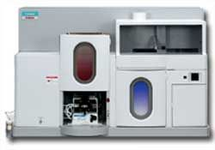
Most metal analyses are best conducted with the iCAP Qc or DMA-80, but the Z-2000 system is occasionally needed for legacy methods. The instrument combines both flame and graphite furnace atomizers along with DC polarized Zeeman background correction for reduced noise and improved sensitivity. The flame system is suitable for ppm-level analyses, and the furnace system is applicable to ppb-level analyses. An autosampler with the furnace system can accommodates up to 60 x 1.5-mL samples.
B. Pre-treatment Equipment
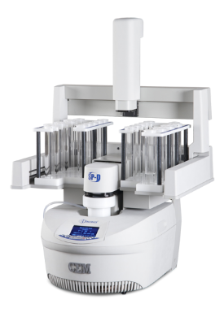
- CEM Discover SP-D Microwave-assisted Sample Digestion System
The SP-D Discover is an automated microwave acid digestion system that produces a clear aqueous digest in 10 minutes or less. It is unique because a small focused cavity allows for rapid heating and cooling of one sample at a time. Active pressure management allows the sample to vent at temperatures and pressures where gasses can be removed effectively while sample and analytes are retained. An autosampler with the system can accommodates up to 48 x 10-mL or 24 x 50-mL samples.

- Environmental Express SC-100 HotBlock® Digestion System
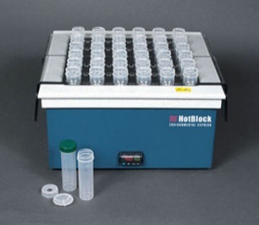
The SC-100 system provides clean, economical digestions for up to 36 x 50-mL samples at the same time. Because heat surrounds each digestion vessel, less energy is required than traditional acid digestions with hot plates. Made of PTFE-coated graphite and other non-metallic materials, HotBlocks eliminate corrosion - a source of sample contamination. HotBlocks use low cost, disposable digestion vessels that speed and simplify digestion procedures.

- SPEX 6775 Freezer/Mill Cryogenic Grinder
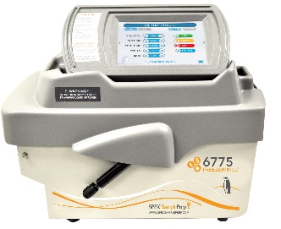
This mill is designed to cryogenically homogenize tough and/or temperature sensitive samples in the range of 0.1 to 5 gram. The mill cools a single sample to cryogenic temperature, then pulverizes it by magnetically shuttling a steel impactor back and forth against two stationary end-plugs. Because the sample vial is closed, the integrity of its contents is maintained, hazardous or critical samples are easily controlled, cleanup is simplified and cross-sample contamination is eliminated.

- BioSpec Mini-BeadBeater-16
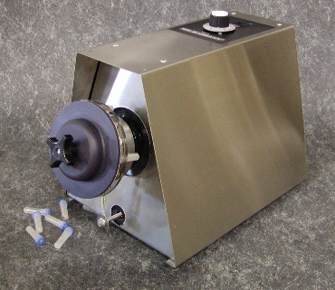
This mill can simultaneously homogenize 16 x 2-mL or 8 x 7-mL samples in less than three minutes. The mill is typically used to disrupt plant and animal tissue by violently agitating samples in screw-cap microvials that contain small ceramic or steel beads and a disruption buffer. Because beads and vials are disposable, there are no cross-contamination concerns when homogenizing multiple samples.

- VWR Drying Oven
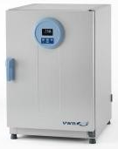
A gravity-convection oven is available to dry solid samples prior to weighing and digestion. Users must specify this pre-treatment and its conditions before submitting samples.

- Cole-Parmer Ultrasonic Cleaner
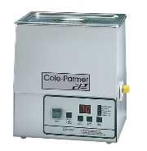
An ultrasonic bath is available to accelerate the dissolution of solid samples or to aid with suspension of nanoparticle samples in aqueous solutions.

- Eppendorf 5430 Centrifuge
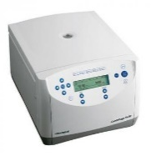
An ambient-temperature centrifuge is available to separate particulate matter from aqueous samples so the particles do not interfere with subsequent sample nebulization and analysis. This benchtop unit provides high centrifugation speed (up to 30,130 x g 17,500 rpm) and is equipped with a rotor that accommodates up to 6 x 15-mL and 6 x 50-mL conical tubes.
C. Handling/Storage Equipment
- Labconco 4’ Vertical Clean Bench
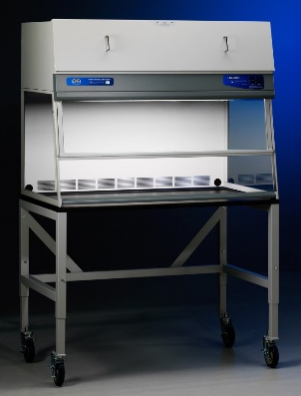
This purifier bench directs HEPA-filtered air downward over the work area to provide ISO Class 5 (formerly Class 100) conditions and to protect the work area from particulate contamination. This level of protection is recommended for the preparation of solutions and samples that require determination at ultra-trace levels.

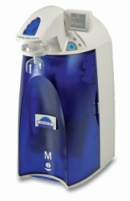
- Millipore Synergy® Water Purification System
The Synergy system produces Type 1 water (ultrapure, 18.2 MΩ·cm at 25 °C) on demand from pretreated (usually distilled) water. All aqueous solutions and samples prepared and processed by the MACF use this water source.

- Ohaus AX124 Analytical Balance
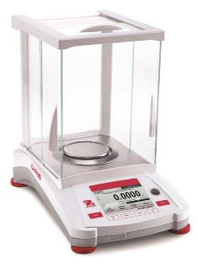
The AX124 is used to weigh solid samples prior to treatment or analysis. It has a readability 0.1 mg and a capacity of 120 g. This balance is commercially calibrated once a year and its calibration is validated over the entire mass range each quarter.

- Eppendorf Research plus™ Variable Adjustable Volume Pipettes
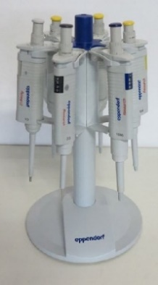
Variable volume pipettes and high-purity disposable tips are available in sizes ranging from 0.5-10 μL (grey), 10-100 μL (yellow), 100-1000 μL (blue), and 1-10 mL (turquoise). These pipettes are used to prepare aqueous standards and to dilute samples prior to analysis. These pipettes are commercially calibrated once a year and their calibration is validated each quarter.

- Sanplatec Dry Keeper Auto-dessicator Cabinet
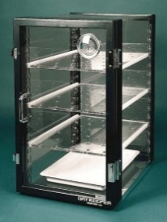
The electronic dehumidification system of the Dry Keeper maintains a permanent desiccant for relative humidity levels between 30-40% while circulating dry air throughout the cabinet. The cabinet is used to store solid certified reference materials (CRMs) that are used routinely for analysis quality control.

- VWR Refrigerator and Freezer
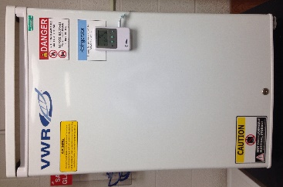
Separate 5-ft³ refrigerator and freezer units are used to store samples and standards as need or specified by users. The temperature in each unit is constantly monitored by NIST traceable thermometer that tracks and stores min/max excursions.

